Vector Calculus: Stewart 16.2 Problem 18

(Stewart, 8e, Calculus, Early Transcendentals)

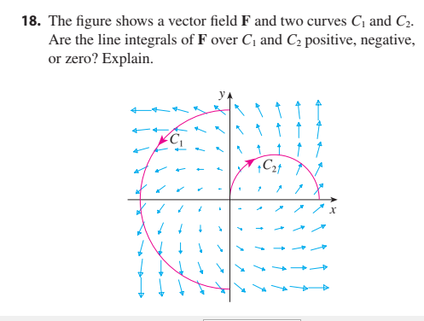

The line integral over a 2-D vector field F may be written
$$\int_{C}^{ }{F\left(x,y\right)∙T\left(x,y\right) ds}$$
where T is the unit tangent vector.

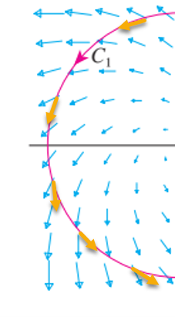

For C1 we draw some tangent vectors
and notice that their dot product is positive.

So we expect the sum of the vector field and dot products
$$\int_{C}^{ }{F\left(x,y\right)∙T\left(x,y\right) ds}$$

to be positive.

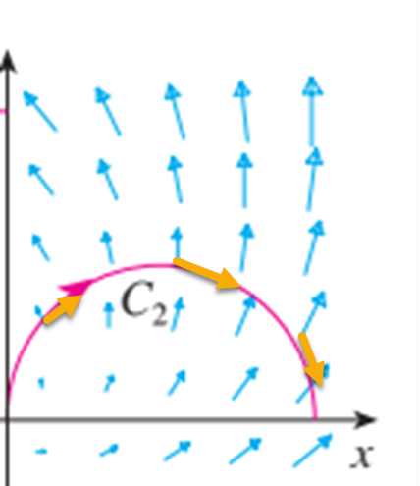
For C2 we draw some tangent vectors
and notice that their dot product is zero or negative.

So we expect the sum of the vector field and dot products
$$\int_{C}^{ }{F\left(x,y\right)∙T\left(x,y\right) ds}$$

to be negative.

Note: compare 16.2 Ex 7

Text’s solution:
